Design presentations

Apply themes to presentations
A fast way to give your slides an attractive, professional look is to apply a theme. You can apply a theme to all slides, or specific slides, for a unique impact.
- On the Design tab, hover over the Themes to preview how it looks, and select the one you like.
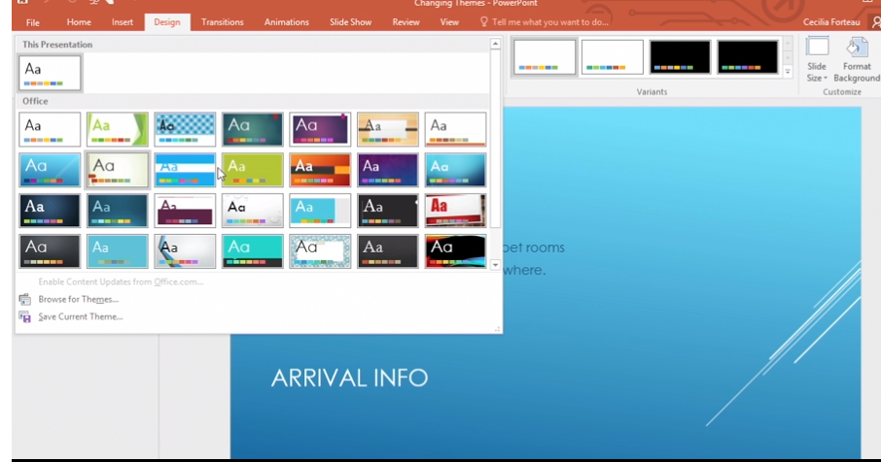
Select More to see more Themes.
By default, the theme you select applies to all slides in your presentation.
- In the Variants group, select More to change Colors, Fonts, Effects, and Background Styles.
- To apply a theme to only one or a few slides:
  - Select the slide or slides.
  - Right click the theme you want, and select Apply to Selected Slides.
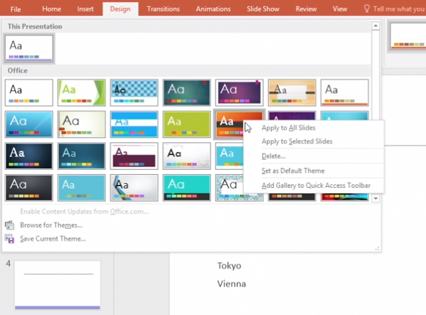

Create, merge, and group objects on a slide
PowerPoint has many standard shapes to add to your presentation. Or you can merge and group objects to make your own.
Create a shape
- Select Home > Shape.
- Select the shape you want to use.
- Click and drag across the slide, drawing the shape to the desired size.
- With the shape selected, you can change the Shape Fill, Shape Outline, or Shape Effects.
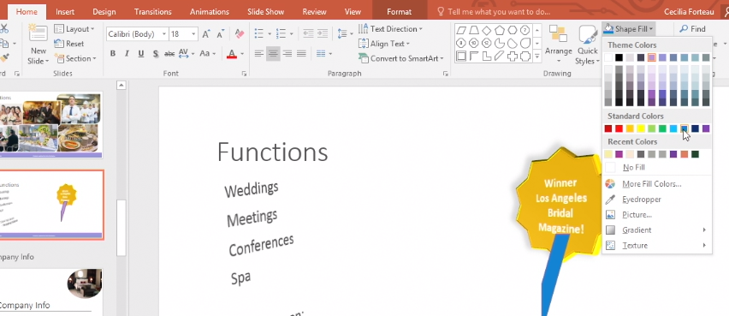
Tip: Select the shape and press Ctrl+D to create a duplicate shape.
Rotate or flip an object
- Select an object.
- Select Drawing Tools Format > Rotate and then select:
  - Rotate Right 90°
  - Rotate Left 90°
  - Flip Vertical
  - Flip Horizontal
  - More Rotation Options
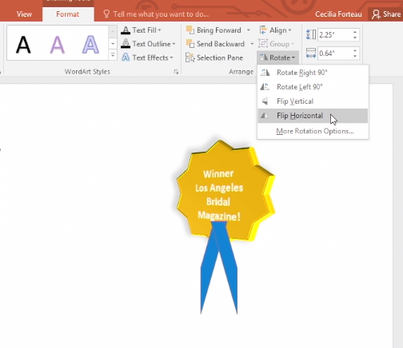
Merge shapes
- Select the shapes to merge. To select several objects, press Shift, and then select each object.
- On the Drawing Tools Format tab, select Merge Shapes, and then pick the option you want:
  - Union: Turns all the selected objects into one object.
  - Combine: Turns all the selected objects into one object, but removes the overlapping portion.
  - Fragment: Turns larger objects into many smaller ones based on how they overlap.
  - Intersect: Trims portions of the larger objects and leaves only the portion that overlaps each object.
  - Subtract: Removes a portion of the last selected object that does not overlap.
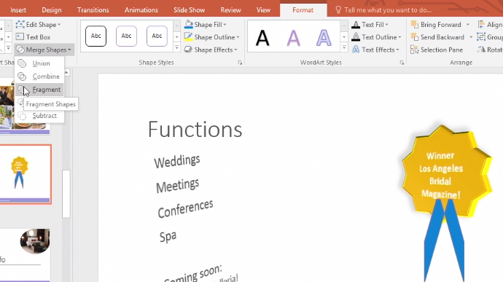
- Once you get the shape you want, you can resize and format the shape, just like a standard shape.
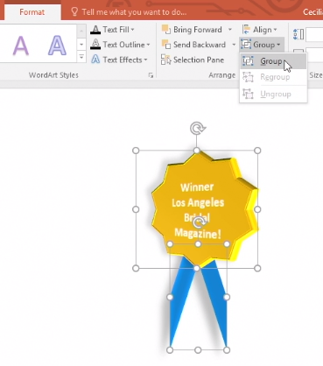
Group objects
- Press and hold Ctrl while you select each object.
- Under the Drawing Tools (or Picture Tools) Format tab, select Group > Group.

Ungroup objects
- Select a grouped object.
- Under the Drawing Tools (or Picture Tools) Format tab, select Group > Ungroup.
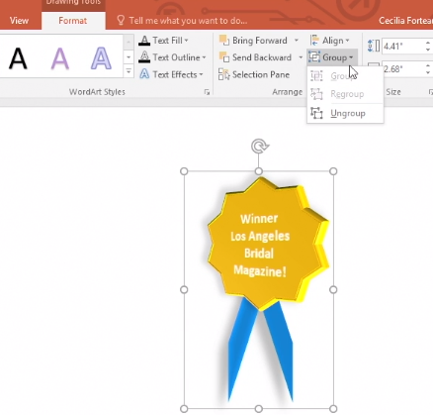

Align and arrange objects on slides
If you have several objects on a PowerPoint slide, you can align and arrange your elements using guides to give your presentation a neat and polished look.
Turn on your guide lines
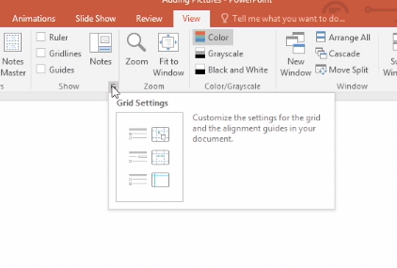
- Select View and then the bottom-right arrow near Guides.

- To turn on or double-check that your guide lines are on, make sure that Display smart guides when shapes are aligned is selected.
- Select OK.
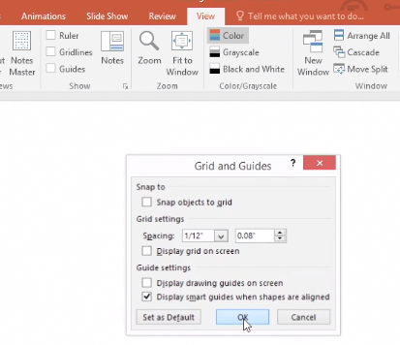
Use guide lines
- Open Windows Explorer, browse to the images or objects you'd like to use, and then drag and drop them into your slides.
- To align and arrange your objects using guide lines:
  - Once you've set the size for one object, you can resize another by selecting and dragging it up or down until a guide line—a dotted red line—appears. This will help align objects at the top and bottom. You need to have at least two objects on the slide.
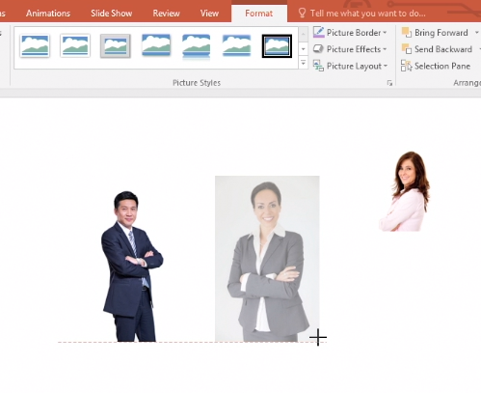
  - To space out your objects, select one and drag it until a red double-arrow line appears—this indicates that your object has been evenly spaced out. You need to have at least three objects on a slide.
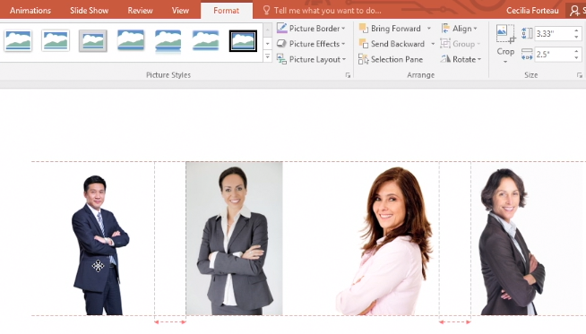
  - To resize all objects at once, hold Shift and select all objects. Select a placeholder corner to slide, shrink, or enlarge your objects collectively.
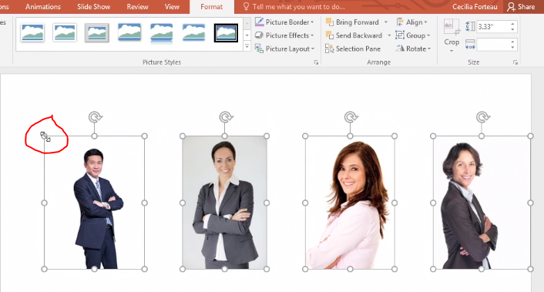

Layer objects on slides
When you add pictures, shapes, or other objects, they can overlap. But you can change the stacking order. For example, you may want one shape that is behind another shape to move to the front.
Move an object to the back or front
- Select the object.
- Right-click and select an option:
  - Send to Back > Send to Back - to move the object behind, or in back of another object.
  - Bring to Front > Bring to Front - to move the object in front of another object.
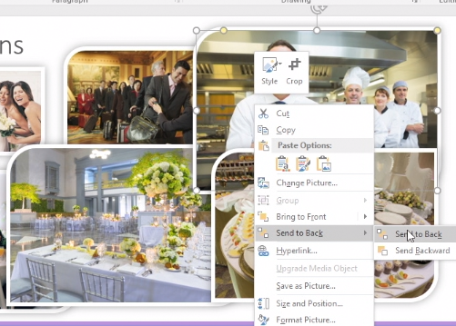

Change slide masters
Use a slide master to add consistency to your colors, fonts, headings, logos, and other styles, and to help unify the form of your presentation.
Change the Slide Master
- Select View > Slide Master.
- Make the text, color, and alignment changes you want.
- Select Close Master View.
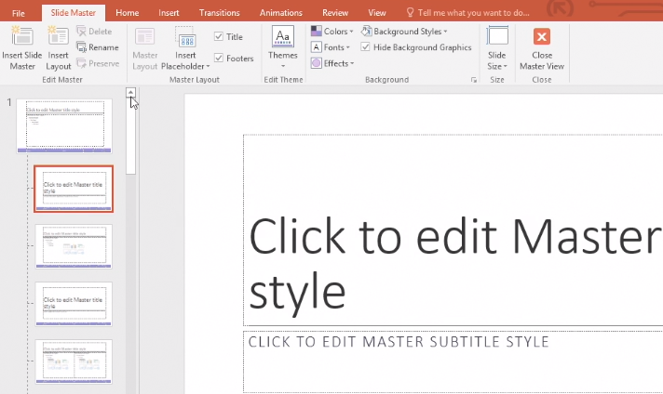

Organize slides into sections
Use sections to organize your slides into meaningful groups, much like you use folders to organize files.
Add a section header
- Select an in-between point in your slides where you'd like to add a section header.
- Select New Slide > Section Header.
Add a section
- Right-click between two slides where you want to add a section.
- Select Section > Add Section.
Collapse or expand a section
- Select the small triangle next to a section name to collapse or expand it.
Tip: To collapse or expand all sections, right-click a section name and select Collapse All or Expand All.
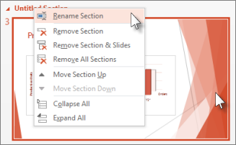
Rename a section
- Right-click the section you want to rename, and select Rename Section.

- Enter a name for the section, and then select Rename.

Remove a section
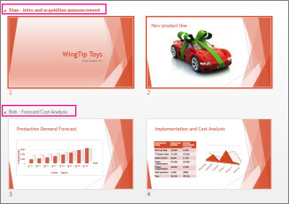
- Right-click the section you want to remove, and then select Remove Section.
View all sections in a presentation
- On the View tab, select Slide Sorter.

Add footers to slides
Add the date and time, slide number, and other information to the bottom of your slides by adding a footer.
Add a footer to a slide
- Select Insert > Header & Footer.
- In the Header & Footer box, on the Slide tab, choose the options you want.
Tip: To hide the footer in the title slide, select the Don't show on title slide checkbox.
- Select Apply to add header and footer to the current slide, or select Apply to All to add the header and footer to all slides.
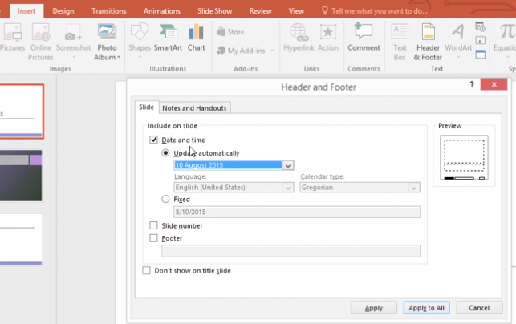

Add transitions between slides
Slide transitions are the animation-like effects that happen when you move from one slide to the next during a presentation. Add slide transitions to bring your presentation to life.
Add a transition to a slide
- Select a slide.
- Select the Transitions tab, and then choose a transition in the Transition gallery.
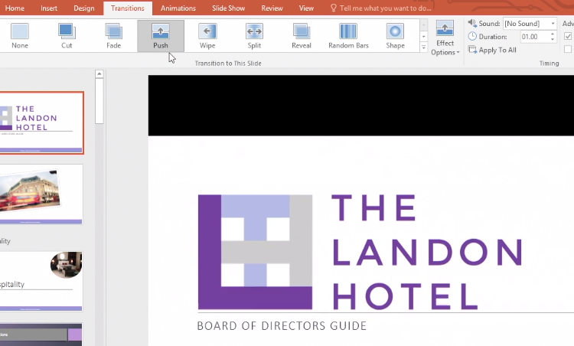
After you choose a transition, you'll see a preview of how it will look.
- To change how the transition looks, select Effect Options.
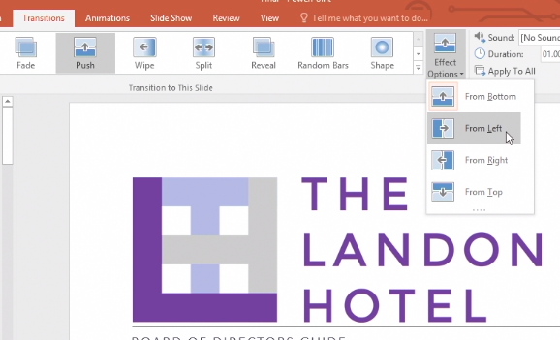
Note: Not every transition has effect options.
- To speed up or slow down the transition, change the number in the Duration box.
Tip: To see your changes in action, select Preview.
- To add a sound, choose one in the Sound box.
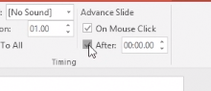
- To make your presentation automatically go to the next slide after a certain amount of time, select the After checkbox, and enter the time you want.
- To add this transition to all slides, select Apply to All.

Change or remove a transition
- Select Transitions > None.
If you'd like to remove all transitions from your slide, select Transitions > None > Apply to All.

Get design ideas for slides
With PowerPoint Designer, just insert a picture and then select the design you want. PowerPoint automatically generates great-looking design ideas, to help you create professional looking slides.
Note: This feature is only available if you have an Office 365 subscription. If you are an Office 365 subscriber, make sure you have the latest version of Office.
Get design ideas
- Select Insert > Pictures and choose the picture you want.
The first time you use Designer, a message appears asking your permission to get design ideas for you.
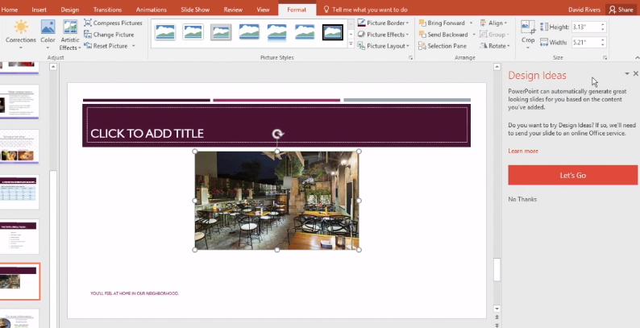
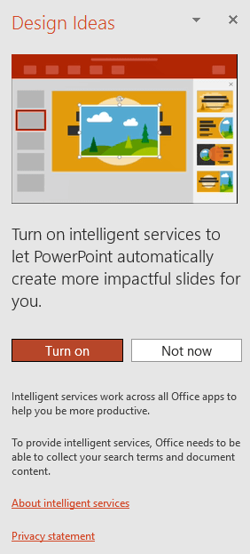
Note: To learn more, see the Microsoft Privacy Statement.

- Select Let's Go to use PowerPoint Designer.
- Select the design you like from the Design Ideas.
You can also bring up Designer by selecting a picture, and then selecting Design > Design Ideas.
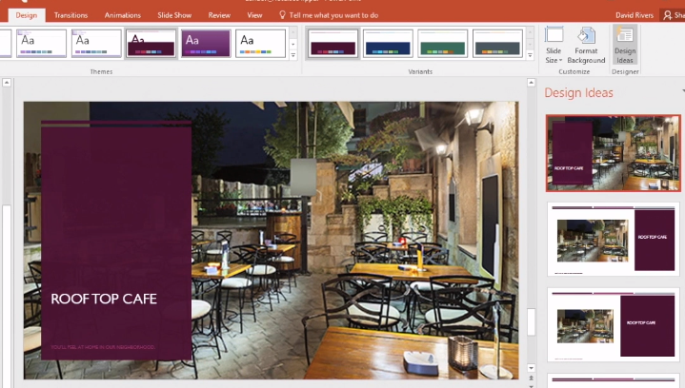
Note: To turn off Design Ideas, select File > Options, and in General, uncheck Automatically show me design ideas in the PowerPoint Designer section.

